Early Explorers
April Newsletter
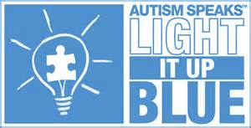 April is national Autism Awareness month! Over the past few years, Early Explorers has had several children with Autism. These children have brought awareness and taught our staff, children, and families many things including acceptance, knowledge of autism, and being different is okay because we are all different in our own way. We would like to show our support by wearing blue on Tuesday, April 5th!
Don’t forget to sign up for conferences April 12th and April 14th! (conferences are optional)
Please make sure the extra clothes in your child’s bin are weather appropriate and currently fit them.
The nice weather is coming! Please bring in sunscreen for your child labeled with their name. Sunscreen must be lotion NOT aerosol.
