Early Explorers
June Newsletter
Donuts with Dads will be Friday, June 17th at drop off!
Early Explorers will be closed Monday, July 4th in observance of Independence day.
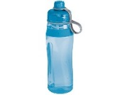Due to licensing regulations we cannot allow water bottles for children in the center. We will offer water to children throughout the day.
If you have any clothing at home labeled EE please return to your child’s teacher. Also be sure your child’s cubby has weather and size appropriate extra clothing.
We have welcomed Miss Paige who will be in Happy Campers, Miss Megan who will be in Out of this World, Miss Ally who will be in Monkey N Around, and Miss Courtney who will be in Into the Jungle! We have also welcomed back Miss Macey and Miss Tori!

