- Early Explorers
August Newsletter
On August 23rd wear stripes or polka dots!
We are always taking donations of plastic bags!
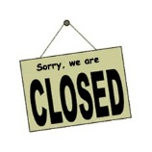Early Explorers will be closed Monday, September 5th in observance of Labor Day.
Like us on Facebook for special notes or upcoming activities!
Please call or email the center if your child will not be here for the day.

We have welcomed Miss Myriah and Miss Nikki who will be center floats!
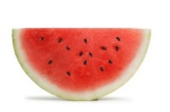Watermelon is the summer's favorite vegetable. Yes, vegetable and not a fruit. It is part of the cucumber, pumpkin, and squash family. Fruit or veggie, this juicy favorite is 92 percent water and the average American eats 16 pounds of watermelon a year.
http://www.whataboutwatermelon.com/index.php/2009/05/did-you-know-16-pounds-of-watermelon-per-year/

