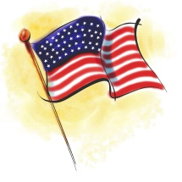 Early Explorers
July Newsletter
The tree and playground dedication for Miss April is Monday, July 18th at 6:00pm.

Thursday, July 20th will be Hawaiian dress up day! Wear your favorite Hawaiian apparel!
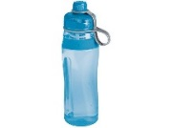Due to licensing regulations we cannot allow water bottles for children in the center. We will offer water to children throughout the day.
If you have any clothing at home labeled EE please return to your child’s teacher. Also be sure your child’s cubby has weather and size appropriate extra clothing.
We have welcomed Miss Hannah who will be in Adventure Island and Miss Taylor who will be a center float.
The month of July is National Ice Cream month!

